Place of event: IBM Bertrange
https://goo.gl/maps/V4BhJzugG1mKXfv88

Using public transportation.
The public transportation is free in Luxembourg, all options are free (bus, train, tram). So, we have some options to reach the event place.
The closest bus stop is Strassen, Atrium.
From the Luxembourg downtown center the best (and direct option) is the Bus Line #10. This line past from downtown center, Central Gare and after goes to event direction.
Bellow you can see the image from the event day, departing from Gare Central to the event place:
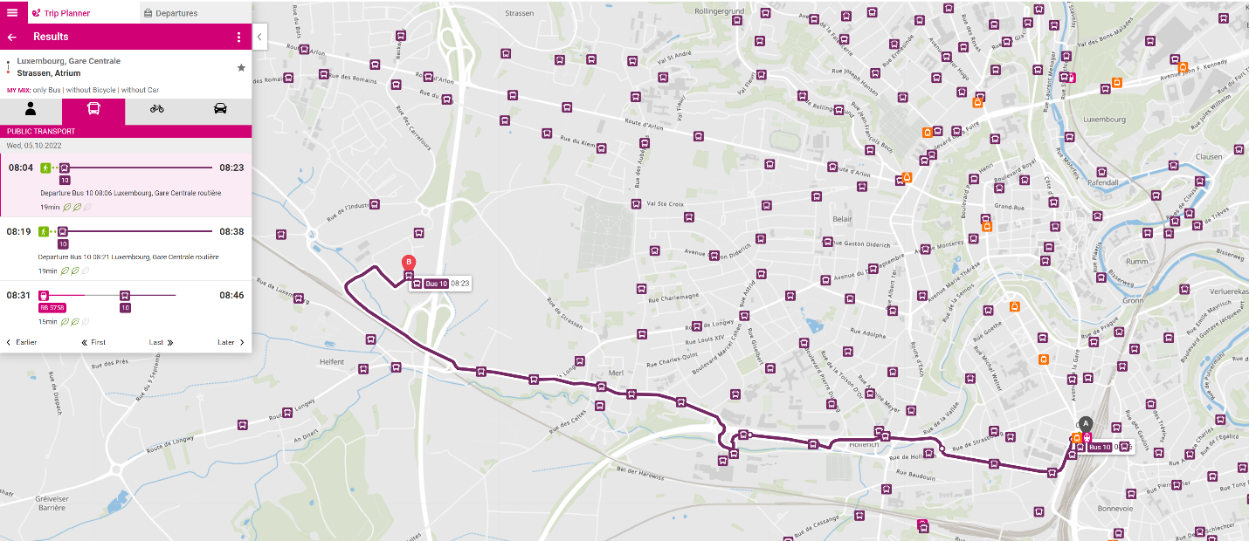
Another option is to use the same line but starting from Hamilus Bus Stop:
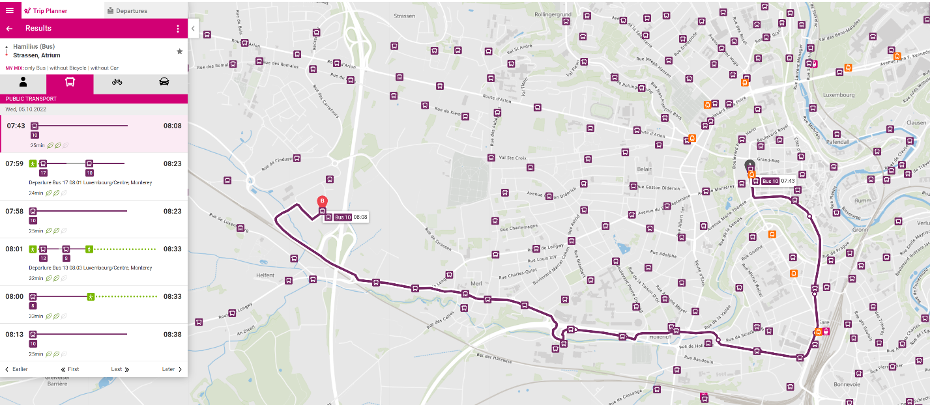
If your hotel is close the Gare Central, the recommendation is use the bus stop in front of gare central.
If your hotel is close to the center, the best bus stop is Hamilus.

You can use the official Luxembourg application Mobiliteit from your phone, or the website below to plan your journey to the event: https://www.mobiliteit.lu/en/journey-planner/

The PDF with all the bus lines can be downloaded here: https://www.mobiliteit.lu/wp-content/uploads/2020/12/Plan-Schematique-2020-Novembre_6.pdf

By Car
Unfortunately, the car parking near of the event can be very busy or difficult to find. Our recommendation is park at Hollerich, P+R Bouillon, and from there use the line 10 to reach the event. The parking is free (until 24hours):
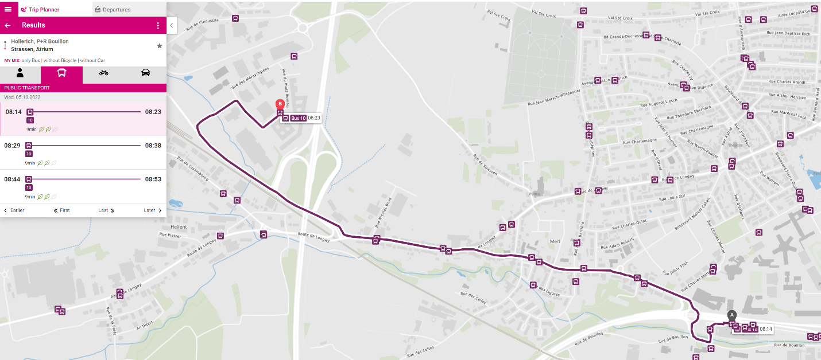
The location from Hollerich, P+R Bouillon is: https://goo.gl/maps/jfmMLz9LASmbEe4YA

